**SQL ASSIGNMENT-1**

**Creating Database: -**

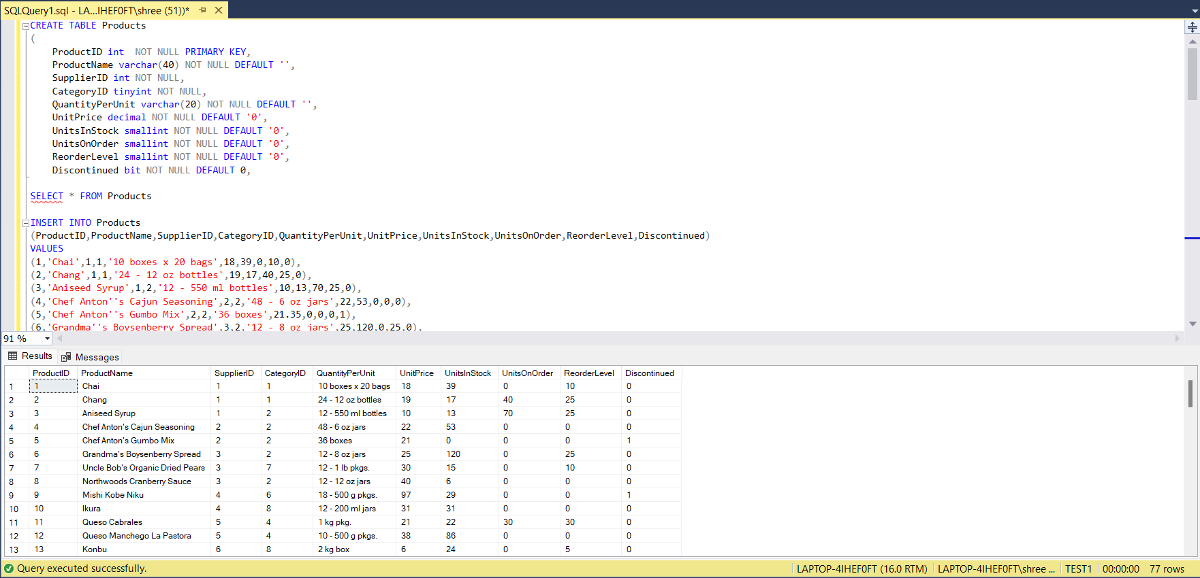

**SQL-Queries**

1) Write a query to get a Product list (id, name, unit price) where current products cost

less than $20.*/

Answer: -

SELECT ProductID,ProductName,UnitPrice FROM Products WHERE (UnitPrice < 20) AND (Discontinued=0);

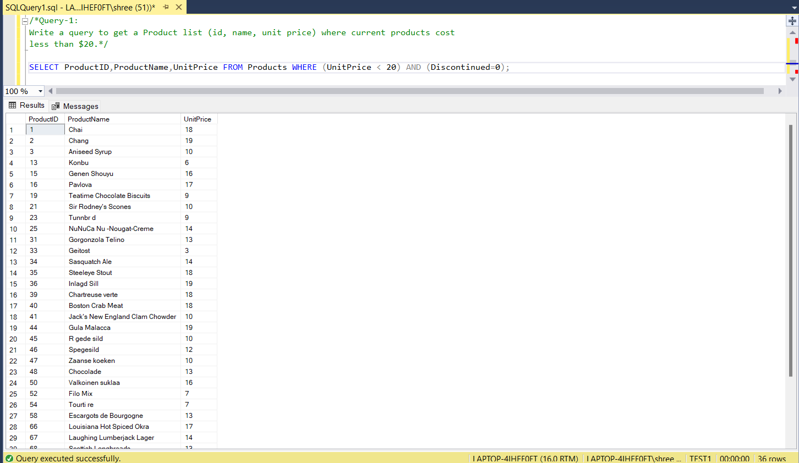

2) Write a query to get Product list (id, name, unit price) where products cost between

$15 and $25.

Answer: -

SELECT ProductID,ProductName,UnitPrice FROM Products WHERE UnitPrice >=15 and UnitPrice <=25

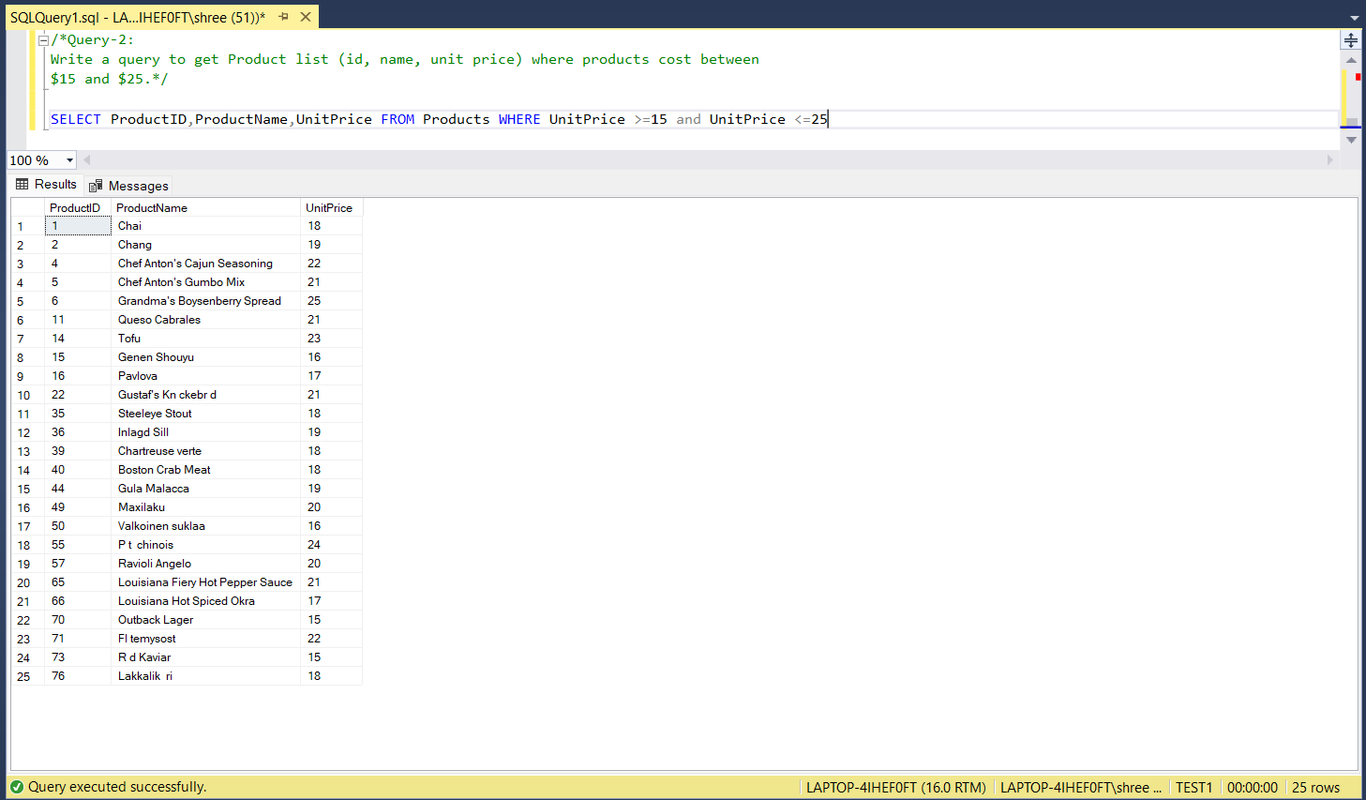

3) Write a query to get Product list (name, unit price) of above average price.

Answer: -

SELECT ProductName, UnitPrice FROM Products WHERE UnitPrice > (SELECT AVG(UnitPrice) From Products)

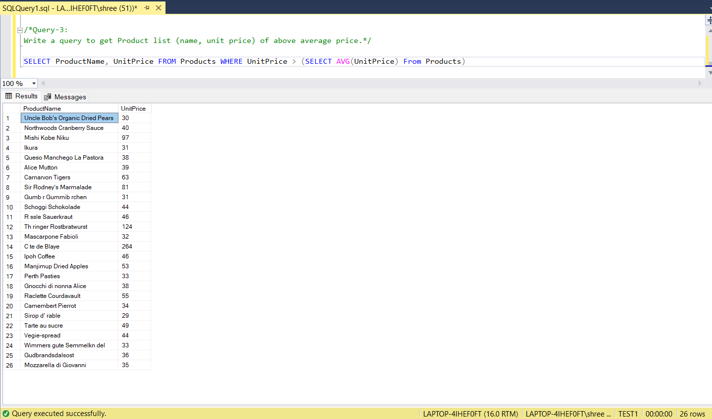

4) Write a query to get Product list (name, unit price) of ten most expensive products.

Answer: -

SELECT Top 10 ProductName,UnitPrice FROM Products ORDER BY UnitPrice DESC

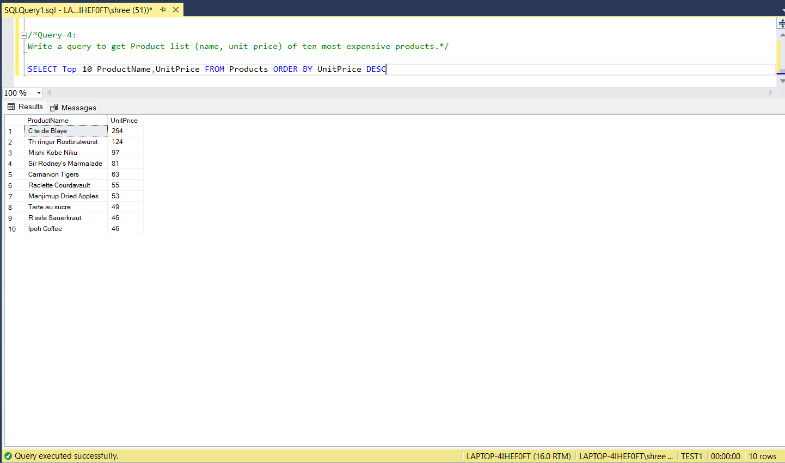

5) Write a query to count current and discontinued products.

Answer: -

SELECT Top 1

(SELECT COUNT(Discontinued) AS CurrentProducts FROM Products GROUP BY Discontinued HAVING Discontinued=0) AS CurrentProducts,

(SELECT COUNT(Discontinued) AS Discontinued FROM Products GROUP BY Discontinued HAVING Discontinued=1) AS Discontinued

FROM Products

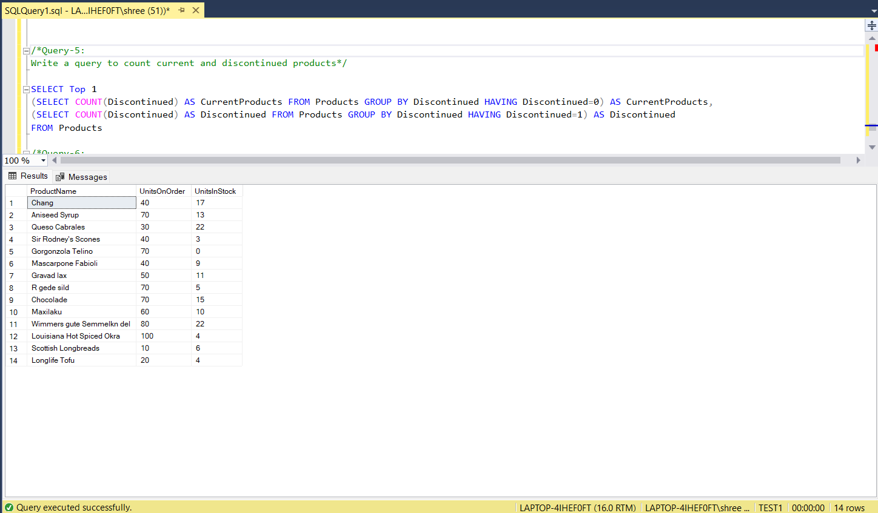

6) Write a query to get Product list (name, units on order , units in stock) of stock is less

than the quantity on order.

Answer: -

SELECT ProductName, UnitsOnOrder, UnitsInStock FROM Products WHERE UnitsInStock < UnitsOnOrder

